
Englisch: Rechtsangelegenheiten
John Buczak, Jennifer Lacchini, Rupert Sage
2nd Semester
B.POLI.B.22
Summer Semester 2023
fhwn.ac.at

Fachhochschule Wiener Neustadt | Johannes Gutenberg-Straße 3 | 2700 Wiener Neustadt
University of Applied Sciences, Wiener Neustadt | Austria


2. Semester
BPF 2016

SS 2017

SS 2017

Course Description
Course Goals | - To expand students’ vocabulary in the professionally-relevant areas below  - To increase oral and written proficiency for communication in the police profession  - To increase comprehension of written and audio materials
Course Content | - Vocabulary: police work, career development, crimes / criminals, crime prevention, the criminal justice system, punishment  - Grammar: revision of tenses; passive; modals  - Communication skills: discussions; paragraph-writing, formal register
Materials  &  Resources | - Handout: “Englisch: Rechtsangelegenheiten”  - Moodle course & materials  - Recommended:  - Quizlet (link on Moodle)  - Murphy, Raymond. English Grammar in Use: A self-study reference and practice book for intermediate students.  - A monolingual learner’s dictionary such as: www.oxfordadvancedlearnersdictionary.com
Assessment
  The final mark consists of the following two elements:
  1. 50% continuous performance
  - 30% participation – preparation, active, voluntary participation in each class
  - 20% discussion forums
  the more you contribute, the more points you can earn
    - for 60% on this task, you must:
      - start 1 discussion in either forum,
      - make a minimum of 5 contributions,
      - contribute to both forums.
    - the quality of original (!) contributions (accuracy, length – 100 words on average) is also taken into consideration
    - please do not use translation programs or copy from the internet!
    - deadline for all contributions: June 16th
  2. 50% test (60 minutes written, 10 minutes oral)
  In order to pass the course, you must:
  - participate actively, voluntarily and made meaningful contributions in class;
  - pass the written and oral tests combined with at least 60%;
  - pass the course overall with 60%.
  If you fail the course:
  - you will be given a resit exam, consisting of a written exam in a similar format and an oral component;
  - each component must be passed with 60%.
Homework & Preparation | This course is worth 3 ECTS. This equals approximately 10 hrs. of work per class / session. This does not include exam preparation.  Written work:  - Homework should give you the opportunity to practice and improve.  - Written homework is corrected but not graded (= not part of your mark).    - Please do your own work. We do not correct translated work or work from other sources. Translated work or work produced/corrected by others will also not benefit your own personal language development.  - We can help you best when you produce your own texts and try out new language and formulations.

Schedule

Unit & Date | Content |  |  | Practice & Preparation  (Your actual assigned tasks may vary slightly from this list!)
Unit & Date | Topics | Related Grammar | Writing Skills
Please prepare for our first class! |  |  |  | - Watch Video 1 on p. 4, take notes. The video can be found on Moodle.  - Look at pp. 6-7 (police units and ranks)  - Look at / complete 1.4 “The Police Station” p. 8
1  WN – February 27  SB – March 3 | 1. The Job of a Police Officer | Present tenses | 7.1 Paragraph structure | - 1.5c Present simple, 1.6c Present simple vs. continuous  - 1.7d Watch Video 2 on police recruitment. Try to answer questions.  - Upload a picture of yourself/your workplace  - Write a TEXT about yourself & your job – Moodle upload, DUE WN March 6, SB March 8  - Start looking at 2.2 Crimes/criminals
2  WN – March 13  SB – March 17 | 2. Crime and Crimes | Past tenses | 7.2-7.4 Topic sentences, supporting and concluding sentences | - 2.3e Crime verbs  - 2.5b Asking questions  - 2.6a Listening 4, 2.6b prepare crime, 2.6c prepare questions  - Consider crime prevention measures 3.1a, 3.1b
3  WN – April 17  SB – April 21 | 3. Crime Prevention | Present perfect | 7.5 Connecting ideas | - 3.5 Mixed verbs  - Write a PARAGRAPH (topic to be assigned) – Moodle upload, DUE WN April 24, SB April 28  - Watch Video 4 3.3b “Crime Prevention against Muggers”
4  WN – May 2  SB – May 5 | 4. Policework | Modals | 7.6 Punctuation | - 4.2e Modals for speculation  - 5.1a Verbs, 5.1b Nouns relating to criminal court/law  - 5.2a Listening 6 – The Criminal Justice Process
5  WN – May 15  SB – May 15 | 5. Law  (Criminal Justice System) | Passive  Past perfect | 7.7 Style & Register | - 5.3e Passive with modals  - 5.5c Simple past or past perfect?  - 6.3 Watch Video 5 on sentencing  - 6.4 Read the text on community payback, complete the sentences  - Write one of the topics from the sample exam (PARAGRAPH) – Moodle upload, DUE June 22
6  WN – June 12  SB – June 2 | 6. Punishments | Future tenses
June 16, 2023 – WRITTEN EXAM 60 min., ORAL EXAM 10 min.
June 16, 2023 – deadline for all discussion forum contributions

1. THE JOB OF A POLICE OFFICER

1.1 Tasks and activities
1.1a VIDEO 1 – The Job of a Policeman/woman
Watch the following video of a police officer describing the job of a policeman/woman.
https://www.youtube.com/watch?v=19jJ_YPxc7c

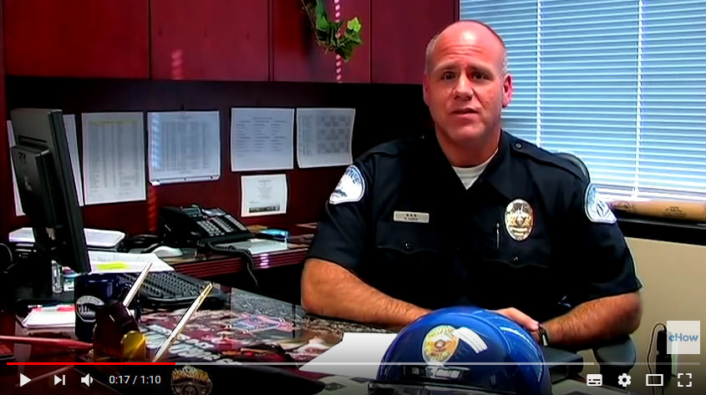

What does Officer Babkin say are the tasks of a police officer?

Which stereotypes does he mention about the police?

1.1b Duties
List as many activities of a police officer that you can think of:

- monitoring the speed of motorists | - securing crosswalks near schools
- investigating crimes

1.2 Police Units / Departments ^{a reference page for you!}
(Source: http://www.gemeinsamsicher.at/downloads/Polizeiglossar_3.0.pdf)

German | English
Abteilung für Sondereinheiten (ASE) | Department for Special Operations Units
alpine Einsatzgruppe (AEG) | alpine response team
Alpinpolizei | alpine police
BAK – Bundesamt zur Korruptionsprävention | Federal Bureau of Anti-Corruption
Bereitschaftseinheit (BE) | Vienna Patrol Support Unit
BFA – Bundesamt für Fremdenwesen und Asyl | Federal Office for Immigration and Asylum
Bildungszentrum (z. B. Bildungszentrum Wien) | police training centre (e.g. Police Training  Centre Vienna)
.BK – Bundeskriminalamt | Criminal Intelligence Service Austria
BM.I – Bundesministerium für Inneres | Federal Ministry of the Interior
(BFA) Bundesamt für Fremdenwesen und Asyl | Federal Office for Immigration and Asylum
(BVT) Bundesamt für Verfassungsschutz und Terrorismusbekämpfung | Federal Agency for State Protection and  Counter Terrorism
Direktion für Spezialeinheiten (DSE) | Directorate for Special Units
EA – Einsatzabteilung | operations department
EE – Einsatzeinheit | crowd and riot control unit
EGFA – Einsatz-, Grenz- und  Fremdenpolizeiliche Abteilung | Operations, Border and Aliens Police  Department
EGS – Einsatzgruppe zur Bekämpfung der  Straßenkriminalität | Anti-Street Crime Operational Team
Einsatz- und Koordinationscenter (EKC) | Operations and Coordination Centre
Einsatzgruppe zur Bekämpfung der  Straßenkriminalität (EGS) | Anti-Street Crime Operational Team
Einsatzkommando Cobra (EKO Cobra) | Special Intervention Unit Cobra
Generaldirektion für die öffentliche Sicherheit | Directorate General for Public Security
Grenzpolizei | border police
GSOD (großer sicherheitspolizeilicher  Ordnungsdienst) | crowd and riot control
Kriminalbeamter/Kriminalbeamtin | CID officer; detective [US]
Kriminalpolizei | criminal investigation department (CID)
Landeskriminalamt (LKA)  (z. B. Landeskriminalamt Steiermark) | provincial CID (e.g. Styria Provincial CID)
Landesleitzentrale (LLZ)  (z. B. Landesleitzentrale Niederösterreich) | provincial control room (e.g. Lower Austria Provincial Control Room)
Landespolizeidirektion (LPD)  (z. B. Landespolizeidirektion Oberösterreich) | provincial police directorate (e.g. Upper Austria Provincial Police Directorate)
Landesverkehrsabteilung (LVA) | provincial traffic department
LVT – Landesamt Verfassungsschutz und  Terrorismusbekämpfung | provincial agency for state protection and  counter terrorism
ODE – Ordnungsdiensteinheit | public order unit
Österreichische Flugpolizei | Austrian Airborne Police
Polizeidiensthundeeinheit (PDHE) | Vienna Police K9 Unit
Polizeiinspektion (PI) | police station
Referat | unit
Schnelle Interventionsgruppe (SIG) | Rapid Response Team
Sicherheitsakademie (.SIAK) | Federal Police Academy
Staatsschutz und Nachrichtendienst (DSN) | State Security Service
WEGA – Wiener Einsatzgruppe  Alarmabteilung | Special Operations Unit WEGA
1.3 Ranks ^{a reference page for you!}

Dienstgrade im österreichischen Exekutivdienst

Laut § 145a (2) BDG 1979 sind für den Exekutivdienst folgende Dienstgrade vorgesehen:
Dienstgrade im österr. Exekutivdienst
(Adapted from source: http://www.gemeinsamsicher.at/downloads/Polizeiglossar_3.1.pdf)

Verwendungsgruppe | DEUTSCH | ENGLISCH
E1  „Leitende Beamtinnen und Beamte“  senior management officers  officers in senior management  senior officers/managers  (senior) commissioned officers | General (Gl) | General
 | Generalmajor (GenMjr) | Major General
 | Brigadier (Bgdr) | Brigadier
 | Oberst (Obst) | Colonel
 | Oberstleutnant (Obstlt) | Lieutenant Colonel
 | Major (Mjr) | Major
 | Hauptmann (Hptm) | Captain
 | Oberleutnant (Oblt) | First Lieutenant
 | Leutnant (Lt) | Second Lieutenant
E 2a  „Dienstführende Beamtinnen und Beamte“  middle management officers  officers in mid-level management  middle-ranking officers  non-commissioned officers | Chefinspektor (ChefInsp) | Sergeant Major
 | Kontrollinspektor (KontrInsp) | First Sergeant
 | Abteilungsinspektor (AbtInsp) | Master Sergeant
 | Bezirksinspektor (BezInsp) | Staff Sergeant
 | Gruppeninspektor (GrInsp) | Sergeant
E 2b  „Eingeteilte Beamte“  subordinate officers  recruits  enlisted officers | Gruppeninspektor (GrInsp) | Leading Senior Officer
 | Revierinspektor (RevInsp) | Senior Officer
 | Inspektor (Insp) | Officer
E 2c  „Exekutivbedienstete  in Polizeigrundausbildung“  officers undergoing basic training for police officers  officers in training | Aspirant (Asp) | Aspirant  (Police cadet)

1.4 The police station

1.4a Vocabulary

This symbol means this (or a similar) activity can also be found on Moodle.
Label the different places in a police station, choosing from the words below:

locker room * drunk tank * control room * sally port * armoury
custody suite / holding cell * briefing room

a | 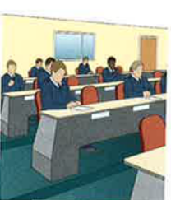 | ___________________ | e | 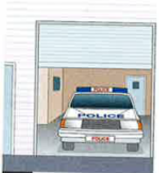 | ___________________
b | 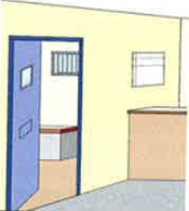 | ___________________ | f | 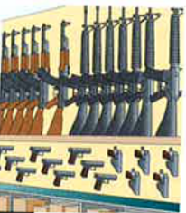 | ___________________
c | 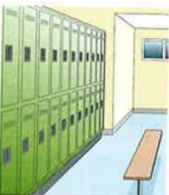 | ___________________ | g | 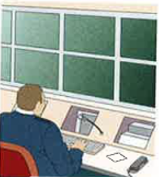 | ___________________
d | 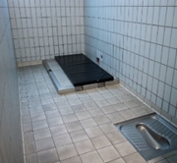 | ___________________

1.4b What happens where?
Match the descriptions with the places above. Write the correct letter (a-g).

1. Weapons and ammunition are stored here. ____
2. People under arrest are processed here. ____
3. Police officers keep their kit and their uniforms here. ____
4. Officers receive their briefing here. ____
5. All calls to the police station are handled here. ____
6. A secure space where vehicles can deliver or pick up people or goods. ____
7. Intoxicated persons are brought here to sober up. ____

Where else does a police officer do his/her work?
1.5 Grammar – Present Simple

1.5a Talking about your job
Don’t forget the third person singular –s!
Careful! We don’t use “do/does” in questions in the present simple when we want to know the subject!
grammar at work
Using the Present Simple

U S E S
for things that are generally true | I am a police officer.  She deals with burglaries.  Joe studies “Police Leadership”.  We stay in the dormitory when we’re at the university
to talk about routines and frequencies | I usually start work at 7:00 a.m.  First thing in the morning, Susan goes on patrol.  Sometimes we have lunch in the cafeteria.
with some signal words | always * sometimes * never * occasionally * frequently * every Friday * often * normally…

N E G A T I V E S
Use “do/does” (except for the verb “be”)
Our station doesn’t have any dog handlers.
We don’t get many calls for domestic violence.
There isn’t much crime in our town.

Q U E S T I O N S
Except for modals and the verb “to be”, questions in the present simple are formed with “do/does”:

Do you know who attacked you?
Does your father speak English?
Can you tell me your name?

We can use questions words as well:

What time do you get off work?
When does your shift end?
What is your rank?
Who do you call most often?
Who calls you on your landline?

1.5b LISTENING 2 – A typical day at work
You are going to hear about a typical working day in the life of Rita Gonzales. Listen to the beginning of her day at work and complete the questions to the answers given.

Example: Which shift _____________________? | The late shift.
- What time _______________________________? | 22:00.
- Why ___________________________________? | To prepare her kit and get ready.
- What time ______________________________? | 23:00.
- Who ___________________________________? | Her partner.
- What area of the city ______________________? | Downtown.
- What _______________________ in the downtown area? | Monitor street activity.
- ____________________________ warm weather? | Yes.

1.5c Practice - Present simple
Complete the exercise below with the correct form of the present simple as a statement, question, or negative:

- Thomas ______________________ (not / swim) in salt water – he only _____________________ (like) freshwater.
- ________________________ (you / want) to have lunch at McDonald’s or Burger King today?
- How much ______________________________________ (a traffic ticket / cost) for speeding?
- I ___________________________ (usually / eat) vegetarian dishes when I go out to eat. But I _____________________________ (not / often / eat) anything with spinach.
- Where __________________________ (you / go) for vacation every summer?
- ______________________________ (your dad / drink) whiskey? I’ll bring him a bottle as a gift.
- My mother ____________________ (make) the best schnitzel! But, she ______________________________ (never / use) pork because we ______________________________ (not / like) it.
- What time ____________________________ (classes / start) every morning in the Police Leadership program?
- There is a car in the lot with its lights on. Who ____________________ (drive) a Corvette?
- Who _________________________ (you / want) to speak to? The manager?

1.6 Grammar – Present Continuous (vs. Simple)

1.6a Describing current activities and actions
grammar at work
Using the Present Continuous

U S E S
happening at or around the moment of speaking | Where are Detectives Smith and Wesson? -- They are questioning some witnesses.  My son is taking piano lessons. (not right now, but around now)
with certain signal words | now * right now * currently * at the moment
exceptions to our routines  (temporary activities) | I usually drink coffee, but today I am drinking tea.  We are wearing bullet-proof vests because we are going to raid a bar
changes and trends | Cybercrime is becoming more and more common.

STATE/STATIVE VERBS
These verbs generally describe a state, not an action. They cannot be used in the continuous.
Common stative verbs | depend, know, mean,  seem, understand | have* (meaning: possess),  look* (meaning: appear),  think* (meaning: consider)

*Some verbs – can be both a stative and an action verb:
have – “besitzen” stative: “We have an electric car.”
have – “nehmen” action: “He has a bath every Sunday night.” (pres. simple)
“He is having a bath right now.” (pres. cont.)
Q U E S T I O N S
Formed with is/am/are + -ing form:

Why are you crying?
What is he holding in his hand?
Is the suspect carrying a weapon?
Are the witnesses still making a statement?

1.6b Identifying Stative Verbs
Choose the correct form of the verb.

1. I think / am thinking of going to China this summer.
2. He thinks / is thinking the world revolves around work.
3. Can you go over that again? I do not understand / am not understanding your point.
4. She doesn’t understand / is not understanding French.
5. What do you look / are you looking at?
6. You look / you are looking really worried. Is everything alright?

1.6c Practice - Present tenses: simple v. continuous?
General duties and routines versus temporary ones
Use the present simple or present continuous as appropriate to complete the sentences below.
- I _________________________ (usually/work) with a partner, but today he’s sick, so I __________________________ (work) alone.
- My partner ________________________ (normally/arrive) at the station at 7:00, but he ________________________ (take) the bus today, so he’ll be late.
- When my partner and I __________________ (be) on patrol, I _______________ (drive).
- Most of the time we _______________________ (use) our mobile phones to communicate, but today we _____________________ (try) out a new radio system.
- I __________________________ (wear) my riot gear because we have a crowd control operation. But I ___________________________ (always/carry) my gun on me when I have normal patrol duty.
- I _____________________ (work) in the CID. We ___________________________ ________________ (currently/investigate) a series of break-ins in eastern Austria.
- On the phone: “Hi, honey. I can’t talk right now. We _________________________ (arrest) a suspect. I’ll call you back later.”

1.7 Talking about your job

1.7a Work relationships & your job
Look at the mindmap below containing words to describe your job and various work relationships.


1.7b Describing one’s job
a. Categorize the phrases/words according to their meaning for you. Do they have a positive meaning? Negative? Neutral?
b. Does the phrase take a verb or any other words? Add if necessary.

Negative | Neutral | Positive
antisocial | to be on day shift  to work the day shift | to have a light workload

1.7c Describing one’s job
Use words and phrases from the previous page to complete these sentences.

- I'm very tired; recently I've had a very heavy _________________.
- I don't want an office job. I don't want to spend all day stuck _____________________.
- I can clock in any time between eight and ten and clock out between four and six; I'm on _________________.
- He's not here this evening, he's working nights; you see, he works ________________.

- Being a nurse is a good job, but you can't go out much with friends. The hours are a bit _________________.


1.7d An exciting job
VIDEO 2 – Police Recruitment Video
Watch the following recruitment video for the New Zealand Police, paying particular attention to the impression versus what is said: https://www.youtube.com/watch?v=f9psILoYmCc

- How does the video portray the profession of a police officer?

- From what you see and hear, what are some of the benefits of being a police officer in New Zealand?

- Discuss: What are the selling points for a career in the Austrian Police Force?

1.8 THE “FH” & Career development
1.8a The FH
Here is a list of vocabulary to enable you to talk about your studies:
The Fachhochschule
Fachhochschule | University of Applied Sciences
Studiengang | degree programme / course
Polizeiliche Führung | Police Leadership
Aufnahmeprüfung; -verfahren | entrance exam; entrance procedure

Studying at the FH
Berufspraktikum | work placement / internship
berufsbegleitend | part-time
Lehrveranstaltungen haben | to have / go to class(es)
Übung // Vorlesung // Seminar | practical // lecture // seminar
eine Prüfung ablegen // bestehen // nicht bestehen // wiederholen | to take/sit // pass // fail // repeat/resit an exam
Referent / Vortragender | lecturer / instructor

Graduating from the FH
Bachelorarbeit | Bachelor’s thesis
ein Studium absolvieren | to complete one’s studies
Studienabschluss | degree
das Studium abschließen | to graduate /ˈɡradʒʊeɪt/
Absolvent/in | graduate /ˈɡradʒʊət/
Sponsion | graduation

1.8b Talking about your studies

degree
placement
graduation
studies
further education

- A: You’re studying at university? I didn’t know police officers in Austria usually get a Bachelor’s or Master’s _______________________.
B: Oh, yes. Since 2006 there has been a programme for non-commissioned officers as part of their _____________________________.
- A: Hi Mark, where have you been? I haven't seen you for ages.
B: No, I was in the Czech Republic doing a work _____________________ at a police station in Prague.
- It's my ______________________ ceremony next week. I’m really looking forward to it. I’ll be glad when I’m finally done with my _______________________.

1.8c Your further career

promoted
senior officer
qualifications
qualify

- The more ______________ you have, the more chance you have of getting a better job.
- A: What will this course _________________ you to do?
B: When I get my degree, I will become a ___________________ in the Austrian Police.
A: Oh, so you’ll be ___________________? That’ll mean more money, too, won’t it?

1.8d Your courses - HERE AT THE UNIVERSITY (This list is ONLY for your reference!)

LV Bezeichnung | Course Title
Anwendung des Projektmanagement in Organisationen | Application of Project Management in Organisations
Anwendung: Qualitative Methoden | Applied Qualitative Methodology
Anwendung: Quantitative Methoden | Applied Quantitative Methodology
Bakkalaureatsseminar - Polizeiliche Führung | Bachelor Seminar - Police Leadership
Bakkalaureatsseminar - Polizeilicher Einsatz | Bachelor Seminar - Police Deployment
Begleitseminar Bachelorarbeiten | Accompanying Seminar Bachelor Thesis
Berufsethik | Business Ethics
Berufspraxis | Practical Training
Beschwerdemanagement | Handling of Complaints
Budgetierung und staatliches Haushaltsrecht | Budgeting and State Household Regulations
Controlling | Controlling
Dienst- und Besoldungsrecht | Public Service and Remuneration Rights
Disziplinarrecht | Disciplinary Rights
Einführung in das Projektmanagement | Introduction to Project Management
Einführung in die Ethik | Introduction to Ethics
Einführung: Qualitative Methoden | Introduction: Qualitative Methodology
Einführung: Quantitative Methoden | Introduction: Quantitative Methodology
Einsatzbearbeitung | Deployment Procedure
Englisch: Einsatzangelegenheiten | English: Deployment Matters
Englisch: Konferenzen und Besprechungen | English: Conferences and Meetings
Englisch: Präsentation von Strategie | English: Strategy Presentation
Englisch: Rechtsangelegenheiten | English: Legal Matters
Englisch: Vorbereitungskurs | English: Preparatory Course
Entscheidungsfindung in Krisensituationen | Decision Making in Crisis Situations
EU-Recht und Grundzüge des Völkerrechts | EU Law and Main Features of International Law
Führung und Organisation | Leadership and Organisation
Führungs- und Entscheidungssystematik | Leadership Methods in Public Services
Grenzdienstangelegenheiten und grenzüberschreitende Polizeikooperation | Border Control Matters
Grundlagen der betrieblichen Informationsverarbeitung
Grundlagen des Managements | Fundamentals of Management
Grundlagen des strategischen Marketings
Grundlagen Menschenrechte | Fundamentals of Human Rights
Grundlagen: Verfassung und Behördenorganisation | Fundamentals of Constitutional Law and Organization of Public Authorities
Informationsvermittlung | The Media of Information
Kommunikation in Konfliktsituationen | Communication in Conflict Situations
Kommunikationstraining | Communication Training
Kosten- und Leistungsrechnung | Cost accounting
Kriminalanalyse | Criminal Strategy
Kriminalpolizeilicher Dienst | Criminal Police Service
Kriminologie, Kriminaltechnik, Erscheinungslehre und Tatort | Criminology, Criminal Technology and Modus Operandi at Crime Scene
Lern- und Präsentationstechniken | Learning and Presentation Techniques
Machtmissbrauch und Korruption | Handling of Misuse of Power and Corruption
Materielles Verwaltungsrecht | Specific Administrative Law
Medien und Öffentlichkeitsarbeit | Handling of Media
Operatives Marketing
Organisations- und Personalentwicklung | Organisation and Personal Development
Personalmanagement | Human Resources
Personalvertretungsrecht | Trade Union Rights
Politologie und Soziologie | Political and Social Science
Polizeiliche Organisationsdynamik
Praxisbegleitseminar | Accompanying Seminar Practical Training
Privatrecht und Zivilprozessrecht | Private and Civil Process Law
Psychologie | Psychology
Psychologische Grundlagen der Kommunikation | Psychological Fundamentals of Communication
Public Management | Public Management
Selbstmanagement und Zeitplanung | Self -Management and Time Management
Sicherheitspolizeigesetz | Security Police Law
Sozialrecht und Bundesbedienstetenschutzrecht | Social- and Federal Employee Rights
Staatspolizeilicher Dienst | State Police Services
Strafrecht und Strafprozessrecht | Criminal Law and Criminal Law Procedure
Taktik und Ordnungsdienst | Tactic and Organisation of Public Services
Tätigkeitsbereiche der Sicherheitsverwaltung | Security Administration Operations Area
Team- und Projektorganisation
Teamführung und Moderation | Team Leadership and Moderation
Übung: Controlling, Kosten- und Leistungsrechnung
Unternehmensmodellierung und Prozessmanagement
Verkehrsdienst | Traffic Services
Vertiefung: Menschenrechte | Consolidation: Human Rights
Vertiefung: Verfassungsrecht und Organisation der Sicherheitsverwaltung | Consolidation of Constitutional Law and Organization of Public Authorities
Verwaltungsverfahrensrecht | Public Management Procedures Law
Waffen- und Geräteausbildung | Weapons and Equipment Instruction
Waffengebrauchsrecht | Weapons Rights
Wirkungsorientierte Ressourcensteuerung

2. CRIME & CRIMES

2.1 Collocations
Collocation refers to a group of two or more words that usually go together, such as:
do homework heavy traffic take a break strong coffee
2.1a Look at the following collocations related to crime:
If you do something illegal/against the law (= wrong), you have committed a crime.

However, law-abiding citizens obey the law.

Most people commit a crime at some time in
their lives, e.g. driving above the speed limit or parking illegally, etc.

If you break the law (= do something wrong/illegal) and commit a crime, you could get into trouble (= be in a bad situation) with the police.

2.1b Collocations - POLICE – CRIMINAL - CRIME

Check the dictionary entries on the right to complete the collocations for the words boldfaced below.

Police | 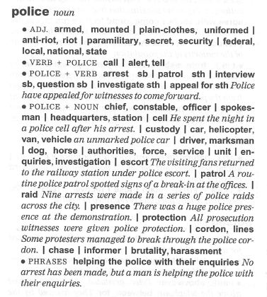
- If you don’t answer my questions, I can escort you to the police s___________ for further questioning.
- They’re advertising for more women to join the police f________.
- P_______-c_________ police had infiltrated the gang so they knew exactly who the leaders were.
- I’ve heard that if you are arrested, you can be held in police c____________ for up to 48 hours before they charge you.
- There was a huge police p__________ at the demonstration.
- A police i_______________ has been launched to try to find the culprit.
- If someone tries to break into your home during the night, don’t try to scare them off. Instead, I’d c_____ the police.

Criminal | 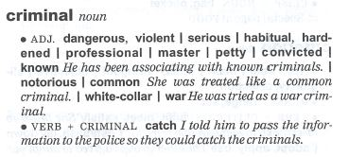
- Jones was described as a h___________ criminal, who showed no compassion for his victims or remorse for his crimes.
- The police hope they will c__________ the criminal before he commits another offense.
- I think few businesses would be willing to hire a c_____________ criminal.

Crime | 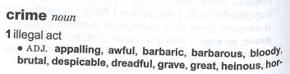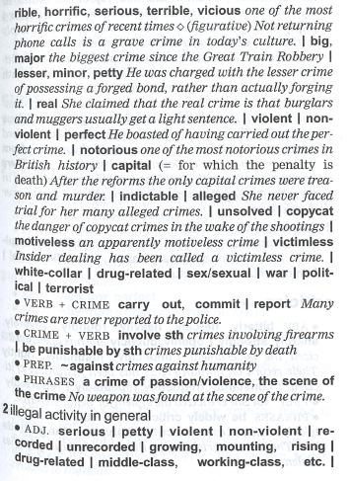  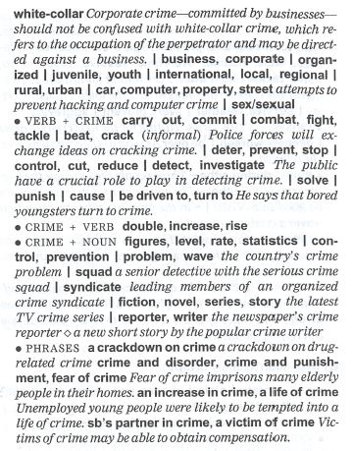
- Although Austria is perceived to be a country with high moral standards, even politicians here are sometimes corrupt and engage in w______-c________ crime.
- Her defense was that she had no intention of killing him, it was a crime o__ p___________.
- There’s quite a lot of p_________ crime in this area, like pickpocketing and jaywalking.
- Three bank robberies and fifteen burglaries in just five days – I’d call that a crime w____________!
- One good way to p____________ crime is to set up a community watch program.
- In Mexico there is a lot of d________-r___________ crime, including the killing of judges, politicians, and police officers who try to fight it.
- V___________ crime often rises during the hot summer months when people become more aggressive.
- We are currently trying to determine if this was an act by the serial killer or a case of c___________ crime.
- The public often complains the police does too little about j________ crime in our society, such as shoplifting and vandalism. But how many such crimes are actually r____________ to the police?
- What can the police do to c___________ crime? Increase video surveillance in public areas?

2.2 Crimes, Offenses, and Anti-Social Behavior

German | Crime | Definition | Criminal | Verb

VIOLENT CRIME
Mord | murder  homicide | killing someone by intention | murderer | to murder
fahrläßige Tötung  Totschlag | (involuntary) manslaughter | killing someone but without planning, killing someone in the heat of the moment | -- | to kill  to commit manslaughter
Körperverletzung | assault  bodily injury | attacking someone physically | assaulter/ assailant | to assault, assail, attack
Amoklauf | mass shooting  shooting spree  stabbing spree  knife rampage | violent and uncontrollable behavior in a group of people with the intent to harm or kill | shooter, gunman  attacker / killer / murderer | to go on a killing/shooting/stabbing spree  to go on a rampage
Schießerei | shooting | an instance of gun violence directed toward a person or group of people | shooter | to shoot (shoot – shot – shot)
Messerstecherei | stabbing | wounding or piercing by the thrust of a pointed object or weapon | stabber | to stab
Überfall (von Personen) | mugging | attacking so violently in order to steal their money | mugger | to mug
Raubüberfall | robbery | stealing from people or places, e.g. banks, by threat or violence | robber | to rob
Vergewaltigung | rape | forcing someone to have sex against their will | rapist | to rape
Terrorismus | terrorism | using violent actions to achieve political aims or force a government to act | terrorist | to attack a person or place

Crimes against freedom
Entführung von Menschen | kidnapping  abduction | taking a person hostage in exchange for money | kidnapper  abductor | to kidnap  to abduct
Stalking | stalking | illegally watching and following a person over a period of time | stalker | to stalk
Menschenhandel | human trafficking | illegally trading human beings for sexual exploitation or forced labor | human trafficker | to traffic humans
Erpressung | blackmail | putting pressure on someone or demanding money by threatening to tell a secret | blackmailer | to blackmail
verbrecherische Erpressung;  Schutzgelderpressung | extortion | obtaining sth from a person by force, intimidation, or undue or illegal power | extortionist | to extort
Nötigung | coercion | using force or the threat of force to make so do sth | coercer | to coerce

Crimes against children
sexuelle Belästigung von Kindern | child molestation | attacking children sexually | child molester | to molest a child
Kindesmisbrauch | child abuse | intentionally treating children in a cruel or violent way by adults | child abuser | to abuse a child
Verwahrlosung | neglect | not giving enough care or attention to sth/so | neglecter | to neglect

Other crimes against the person
Belästigung | harassment | making a person feel anxious and unhappy | -- | to harass
Mobbing | bullying | abusing and mistreating someone more vulnerable | bully | to bully

Crimes against property
Taschendiebstahl | pickpocketing | stealing things/money from so’s pockets | pickpocket | to pickpocket
Ladendiebstahl | shoplifting | stealing from shops when they are open | shoplifter | to shoplift
Diebstahl | theft | general word for stealing | singular thief  plural thieves | to steal (steal – stole – stolen)
Einbruchdiebstahl | burglary | breaking into a shop/house and stealing things | burglar | to burgle  to break in and steal
Hausfriedensbruch | breaking and entering | entering a building illegally and using force | burglar  housebreaker | to break in and enter
Hausfriedensbruch | home invasion | commonly used for houses / apartments | burglar  housebreaker | to break in and enter
Besitzstörung | trespass (BE)  trespassing (AE) | going onto someone else’s land without permission | trespasser | to trespass
Brandstiftung, -legung | arson | setting fire to something in a criminal way | arsonist | to set fire to (set – set – set)  to commit arson
Plünderung | looting | stealing things from buildings after a fire, riot… | looter | to loot
unbefugter Gebrauch von Fahrzeugen | joyriding | driving around for enjoyment in a car you have stolen | joyrider | to go for a joyride
Vandalismus | vandalism | destroying property | vandal | to vandalize
Entführung von Transportmitteln | hijacking | using violence to take control of a vehicle | hijacker | to hijack

crimes against Public order
Hooliganismus | hooliganism | making trouble at a match | hooligan | to make trouble
Herumlungern | loitering | standing and waiting somewhere with no obvious reason | loiterer | to loiter
Autofahren unter Alkoholeinfluss | drink/drunk driving | driving while intoxicated | drink/drunk driver | to drive drunk (drive -drove – driven)
Rechtsextremism | right-wing extremism | opposing fundamental national values and beliefs | right-wing extremist | ≈to participate in right-wing extremist activities

Consensual / Victimless crime
Prostitution | prostitution/ solicitation | engaging in sex in exchange for money | prostitute  (john=hirer; pimp=manager) | to prostitute oneself
Drogenverkauf | drug dealing  drug selling | selling illegal drugs | drug dealer | to deal/sell drugs (sell – sold – sold)
Drogenhandel | drug trafficking | involving manufacturing, distributing and selling of illegal drugs | drug trafficker | to traffic drugs
Schmuggeln | smuggling | taking something illegally into another country | smuggler | to smuggle
Menschenschmuggel | people smuggling | bringing people across a border illegally | people smuggler | to smuggle people

Crimes – Intention to deceive
Betrug | fraud | deceiving so to get money or goods illegally | fraudster | to commit fraud
Fälschung von Geld, Gegenständen | counterfeiting | making exact copies of sth to make people believe it is real | counterfeiter | to counterfeit
Fälschung von Dokumenten | forgery | making illegal copies of sth in order to deceive | forger | to forge

Financial crime
Pfuschen | undeclared work | doing (undeclared) work on the side | undeclared worker | to do (undeclared) work on the side (do – did – done)
Veruntreuung, Unterschlagung | embezzlement  (misappropriation) | stealing money in your care or belongs to an organization that you work for | embezzler | to embezzle
Steuerhinterziehung | tax evasion | deliberately not paying taxes | tax evader | to evade taxes
Insiderhandel | insider trading | illegal buying and selling of shares by someone who has specialist knowledge of a company | insider trader | to commit insider trading
Geldwäscherei | money laundering | moving money obtained illegally so that its origin cannot be traced | money launderer | to launder money
Bestechung | bribery | giving money or sth valuable to persuade so to help you | briber | to bribe

Tech crime
Raubkopieren | pirating, piracy | making illegal copies | video or music pirate | to pirate music, etc.
Hacking | hacking | gaining unauthorized access to data in a system or computer | hacker | to hack
Internetkriminalität | cybercrime | committing crime using the internet | cybercriminal | to commit cybercrime

2.3 Grammar – Past Tense

2.3a Talking about Past Actions
some signal words:

while * at 7:30
*remember the irregular verb forms
grammar at work
Using the Past Tense

SIMPLE PAST
U S E S
- To talk about completed actions and routine actions:
We lived in Canada when I was a child.
The police caught* the thief at the border.
I got* up, had* breakfast, showered, and went* to work. (series of events)
After every killing, the murderer took* the victim’s shoes. (“habit” or routine)
- With some signal words when talking about the past

Q U E S T I O N S & N E G A T I V E S

Formed with “did” + infinitive (except for the verb “be”):
What time did you hear the noise?
Did you study at the FHWN?
Were you on duty when the call came in?

PAST CONTINUOUS
U S E S
- To talk about actions in progress at a certain time in the past:
What were you doing at the time of the murder?
I was watching the news at 7:30 last night.
- Often used together with the simple past:
The burglar was opening the safe when the police arrived.

always * sometimes * never * occasionally * frequently * every Friday * often * normally * last (year / month …) * yesterday * ago * in 1992 * on Monday * when * what time

2.3b Practice – Irregular verbs
Complete the following sentences to describe completed actions in the past.

- My unit __________________________ (spend) all day yesterday looking for the suspect, but we _____________________ (not / find) him.
- Joe and I ________________________ (know) each other a long time ago from the police academy. We _______________________ (run) 10 kilometers together every morning.
- We ________________________ (swim) every day during our last vacation.
- The terrorist ________________________ (drive) into a crowd of people with his truck.
- When I __________________ (go) to school, I _____________________ (always / do) my homework every afternoon.
- I ___________________________ (forget) my wedding anniversary once. Big mistake!
- My partner and I _________________________ (catch) two burglars last night.

2.3c Crime verbs 1
Use the past tense of the correct verb to complete the sentence:
burgle snatch vandalise mug forge embezzle
- Jill's very upset. A man ________________ her handbag as she came out of the bank.
- Two boys ____________________ the telephone box at the end of our street last week.
- A Romanian gang ____________________________ three houses in our street in the last month.
- A masked person _______________________ my boyfriend on his way home from work last night.
- Over a period of five years Mr Martin _________________________ more than £15,000 from the company he worked for.
- One of my colleagues __________________ the boss's signature on a company cheque and got caught.

An object is stolen,
whereas a person or place is robbed.

2.3d Crime verbs 2 – rob or steal?
Put the right form of either rob or steal in the sentences below.
1. Last night an armed gang ______________ the post office. They ______________ $2000.
2. Two armed men _________________ a bank in central London this morning.
3. Somebody _______________ my bike from outside the school yesterday.
4. A young boy ________________ a package of bubble gum from the supermarket.

2.3e Crime verbs 3
Use the correct form of these verbs (the past tense!) to complete the sentences:
murder rape rob set fire to kidnap smuggle
- Firefighters were called to a pub in Croydon this morning. Police believe a man ____________________ the building after an argument with the owner last week.
- Police believe that Jenkins ______________________ his victim at his home and then drove the body out to the forest, where it was found this morning.
- Witnesses report that a man ___________________ a boy who was playing outside his house this afternoon. The man forced him into a car. He has not yet made contact with the boy's family.
- Authorities believe that Miss Davies ____________________ £100,000 worth of heroin into the country.
- Two men _____________________ a post office in Brighton this afternoon. They got away with £20,000.
- An unidentified person _____________________ a young woman on a train between London and Oxford last night. Police think her attacker may be the same man they believe is responsible for three other similar sexual assaults in recent weeks.

2.4 Listening 3 - Crime Doesn’t Pay
2.4a Before you listen…
What do these words from the news report mean?

- armoured car
- getaway
- hiding place
- escape route
- handpicked
- without a hitch
- attempted
- in the course of
- shifted

2.4b While you are listening…
Listen to three stories about crimes that went wrong. Fill in the details below.
 | What was stolen? From where? | What went wrong?
Story 1
Story 2
Story 5

2.4c How good is your memory?
Join the words or phrases in groups of three or four: each group relates to one story. The first one has been started for you:
grocery store
armoured car
eyeholes
30-pound bags
Providence, Rhode Island
pennies
a lot of cash
injury
London
paper bag
2.5 past simple / continuous to talk about crime

2.5a Practice – Past Continuous or Simple?
Complete the following sentences to describe actions in progress or to describe situations in the past.

- Mr. Jones was getting money from the bank when a bank robber _______________ (come) in.
- Josephine ____________________________ (not/see) the face of the man who robbed the bank because he _________________________ (wear) a ski mask.
- What ___________________________ (you / do) at the time of the murder yesterday evening?
- I _________________ (have) a car accident yesterday. I __________________ (talk) on my cell phone when it ____________________ (happen).
- I ___________________ (have) a car accident yesterday. I ________________ (get) out of the car and _____________________ (fill) out the accident report with the other person who was involved.
2.5b Asking questions (interrogating and interviewing).
Formulate questions, deciding which past tense is more appropriate.

Example: color getaway car? What color was the getaway car?
1. bank robber / accomplice?
2. what stolen?
3. who / call / police?
4. bank robber / say?
5. bank robber / ski mask?
6. bank robber armed?
7. bank robber gun?
8. what / you / do / when / bank robber / enter / building?
2.6 Reporting a Crime

2.6a LISTENING 4

Listen to the following example of a victim who is reporting a crime. Complete the crime report below:
Crime Management Unit
TOWER HILL POLICE STATION
SERVING THE COMMUNITY
Crime Report
Date: March 11th
Constable: ________________________________________________
Victim name: ________________________________________________
Victim contact details: ________________________________________________ ________________________________________________________________________________________________

Type of crime: _______________________________________________
Details of any item(s) stolen: ________________________________________ ________________________________________________________________________________________________

Location of incident: ________________________________________________
Time of incident: _______________________________________________

Description of suspect: ________________________________________________ ________________________________________________

Witnesses: ________________________________________________ Crime reference number: _______________________________________________


2.6b Role play 1 - Witness
This is for Role Play 2

In this part, you are going to be the witness who reports a crime.
Crime Management Unit
UNIVERSITY OF APPLIED SCIENCES POLICE STATION
SERVING THE COMMUNITY
Crime Report
Date: _____________________________________
Constable: ________________________________________________
Witness name: ________________________________________________
Witness contact details: ________________________________________________
________________________________________________

Type of crime: ________________________________________________
Details of crime: ________________________________________________ ________________________________________________________________________________________________

Location of incident: ________________________________________________
Time of incident: ________________________________________________

Description of suspect: _______________________________________________
Other witnesses: ___________________________________________

Prepare for the role play by inventing a crime:

- type of crime (any other relevant details)

- time & location

- description of suspect

Be prepared to invent any other information the police officer may ask of you.

2.6c Role play 2 – Police officer
In this part, you are going to be the police officer.

A witness has come to the police station to report a crime. Ask the relevant questions to complete the crime report.

3. CRIME PREVENTION

3.1 MEASURES BY The STATE
3.1a What can governments do to prevent crime (= stop crime happening) or reduce it (= make it less)? These things happen in some countries. What other measures can you think of?
- The police carry guns. (= have guns)
- The police are allowed to (= are permitted to/can) stop anyone in the street and ask them questions.
- Criminals receive tough (= hard) punishments, e.g. go to prison for long periods.
- There is capital punishment (= death, e.g. by injection or electric chair) for some crimes.

3.1b Discussion
What can be done by the police to deal with and prevent the following situations?

You can use modal verbs to express your opinion:
The authorities / police / government should / ought to / could / have to…

3.2 Protecting property
3.2a What can people do to protect their homes and property? They can do these things. What else can we do?
- Install a burglar alarm.
- Put money and valuables (= things worth a lot of money) in a safe.
- Leave lights on at home when they go out.
- Lock doors and windows when they go out.

3.2b Home security items
Label the pictures below, using these words:

door chain * lock * spyhole * bolt * fence * motion-detection lighting * burglar alarm * timer switch
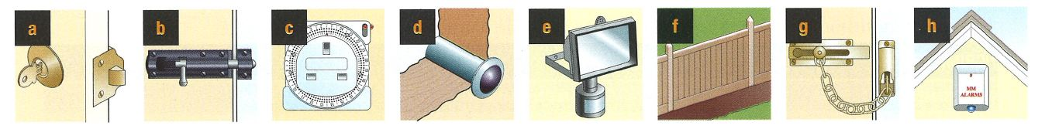
____________ ___________ ___________ ____________
___________ __________ ___________ ___________

3.2c Weaknesses in Security

Look at the outside of this house. Identify as many security problems as you can.

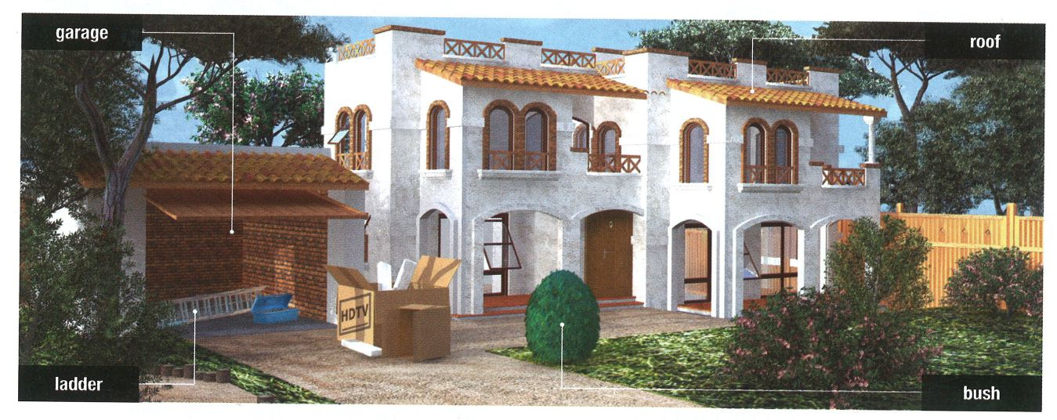

What advice would you give the homeowner?

3.2dVIDEO 3 – Crime Prevention for Businesses
Watch the news report and take notes on how businesses can protect themselves against crime: https://www.youtube.com/watch?v=G62Ev5sveaI
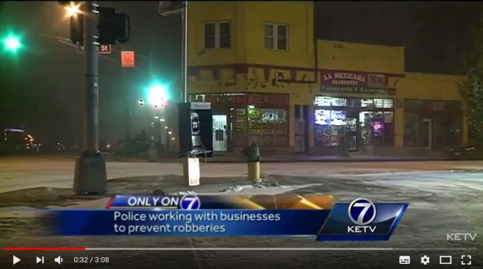

3.3 PERSONAL PROTECTION
3.3a Protecting yourself
What should people (especially women and the elderly) do to protect themselves (= keep themselves safe).
- Avoid (= keep away from) dark streets late at night (e.g. midnight).
- Avoid wearing (= try not to wear) expensive rings or watches. [Note the -ing form after 'avoid'.]
- Be alert when someone calls on the phone, claiming to be your nephew or grandchild (“grandparent scam”).

3.3bVIDEO 4 – Crime Prevention against Muggers
Watch the following video of an interview with a convicted mugger: https://www.youtube.com/watch?v=iHFKKewlnwU
What advice does the convicted mugger give about how people can protect themselves?

3.4 Grammar – Past vs. Present Perfect

3.4a Talking about events connected to the present
Signal words:
ago, last week, last year, on Tuesday, when I was a child
Signal words:
just, already, ever, never, recently, so far, up until now, for, since
grammar at work
Talking about the Past & Present

PRESENT PERFECT | SIMPLE PAST
for recent past actions with  - a connection to the present  - and/or the chance of this action being repeated.  A major burglary has just occurred at a famous Viennese jeweller. | for completed events or actions  A break-in occurred last night at the Bank Austria on 1st Street.
We have caught 6 members of the gang so far. | We caught 6 members of the gang last year.
He has worked in this unit for 4 years. | He worked in this unit for 4 years.

3.4b Practice – Present perfect or simple past
Look for the signal words. Choose between the present perfect simple and the simple past.

- Last year in January, burglars ____________________ (break) into our house.
- Since we moved into this house, burglars _______________________ (break) in twice.
- I _______________________ (work) in Vienna from 1995-2000. Since 2000 I __________________________ (work) in St. Pölten.
- At my last job, we ____________________ (solve) 9 out of 10 crimes. In my present job, we ______________________ (solve) all of them so far.
- During the first 3 years in the police force, I ___________________ (injure) myself once. Since 2013, I _____________________ (hurt) myself 5 times!
- When I was an air marshal, I __________________ (fly) somewhere nearly every other day. Since then, I _______________________ (only/be) on a plane once!

3.4c Present Perfect Simple vs. Continuous
grammar at work
Using the Present Perfect

PRESENT PERFECT SIMPLE | PRESENT PERFECT CONTINUOUS
to talk about recent actions with a connection to the present  (its importance now) | to talk about events or actions  that started in the past  and are still continuing
We’ve installed some new equipment in our patrol car. (I don’t say specifically “when”)  The police have finally caught “Wiener Würger”! (recent news, announcements) | We have been investigating a string of car thefts in the area. (we haven’t solved it yet!)  My partner has been interviewing witnesses all morning. (it’s still morning, he’s still inter-viewing incomplete period of time)  The juvenile delinquent has been taking drugs since he was 11. (he still takes drugs…)
with stative verbs
I have been a police officer for over 15 years. (still am, but “be” is stative)
We have known each other since police school. (still do, but “know” is stative)

3.4d Practice – Present perfect simple vs. continuous
You visit the owners of the house in 3.2c a few weeks after giving them advice on security. Listen to the changes or improvements they have made (present perfect simple) and those they have started and are still working on (present perfect continuous) since your visit.

- My spouse _________________________ (remove) the ladder from the garage, so that’s no longer there.
- We ___________________________ (close) the windows whenever we leave the house.
- We ___________________________ (start) locking the garage door.
- I ____________________________ (throw) away the empty TV box.
- We’re not quite finished yet, but our landscapers _______________________________ (cut) the bushes and shrubs around our house.
- The local security firm ___________________________ (install) a burglar alarm.
- My brother _______________________________ (replace) the wooden fence with a chain link (Maschendraht) one, but he won’t be finished until tomorrow.
3.5 Mixed verbs
You have been invited to talk to a group of Britons and Americans living in Austria about security in Austria.

Introduce yourself and share information about your past experience, choosing the correct tenses (all present, past and present perfect tenses!).

Good evening, ladies and gentlemen. Thank you for inviting me here tonight to talk to you about security. My name is Officer Caine. I ¹_________________________ (be) a police officer for over 25 years now. I ²__________________________ (start) my career in Tyrol, but after 15 years in the west of Austria, I ³_________________________ (decide) to move to the east where I could experience a different pace of life. I ⁴________________________ (get) married 10 years ago and ⁵______________________________ (recently / build) a new home near Lake Neusiedl. I ⁶_______________________________ (commute) every day to Vienna where I ⁷________________________________ (serve) at the same station for the past 8 years. As our main area of responsibility, my team and I ⁸______________________ (inform) communities about ways to secure their homes and protect themselves. I ⁹_________________________ (give) talks on security on a regular basis. In the past few years, I ¹⁰________________________________ (talk) to the public over 100 times about how to protect their property. I ¹¹_________________________ (enjoy) my work immensely.
Now, let me continue by saying a few words about the general situation in Austria. You may know by now that Austria ¹²________________________ (be) generally quite a safe place to live in. Of course, crime ¹³_____________________________ (occur) here as well as in any other country, yet, overall, crimes against the person ¹⁴__________________________ (be) relatively low. On the other hand, we ¹⁵__________________________________ (experience) a general upward trend over the past few years in regards to crimes against property – more and more criminal gangs from Eastern Europe ¹⁶________________________________ (break) into homes, especially in the evening hours. The Austrian Police Force ¹⁷______________________________ (do) everything in its power to counteract this trend, but we ¹⁸__________________________ (need) your help.



4. POLICE WORK – AFTER THE CRIME

4.1 From the Crime
to the Court
When someone commits a crime,
the police do a number of things:

3
If they are sure that the person committed the crime, the person is ch________ with the crime.
For a serious crime (e.g. murder),
the person must then go to co________ for trial.
2
If they catch the person they believe is responsible for the crime, they will ar_________ him/her.
The suspect is ta________ in a police car to the police station to be qu_____________.
S/he is kept in cu__________ or released on ba________.
1
They investigate the crime.
They la______ an investigation / enquiry.
They se_______ the area.
They in____________ witnesses and ta_______ witness statements.
They ga_________ evidence, such as DNA.

The suspect…
- He was accused of _________________ (rob) a local shop.
- He admitted _______________ (steal) money from his employers.
- He denied ___________________ (be involve) himself, but admitted that he knew who had done it.
- He was let off ______ a fine.
- He was warned ___________________ (drive) so fast in the future.

Aufklärungsquote:
solve rate
clear-up rate
clearance rate

4.2 Grammar – Modals: Form

4.2a How to use modals
grammar at work
Using Modals - Form
There are generally two main constructions:
PRESENT | modal + (not) + infinitive | may do  might leave  …
Examples: | You could try contacting a colleague for some more information about the suspect.  The witness might know where the suspect fled to.
PAST | modal + (not) + have + past participle | could have taken  should have told  …
Examples: | The burglar might have entered the house through the window.  I can’t find my phone. – You can’t have left it at home. You never forget it.

4.2b Form
Correct these sentences using modals. Why are they wrong?

 | Reason
Example:  written  Your partner might have write down the wrong address. | wrong past participle
- My brother mays visit us this summer.
- You should to use the safety on your handgun.
- My boss can’t find his keys. He might has lost them. He may have leave them in his office.
- I may can give you my telephone number.
- We should have not eaten at that restaurant. I feel sick!

4.2c Practice
Read the stories and choose/complete the right form/meaning.
Story A
A 15-year-old schoolgirl has been sent to prison in Germany for missing school. Maggie Haineder, from Goerlitz in Saxony, was given two weeks in prison after she missed more than three weeks of school. One critic said, “The judge’s decision is crazy,” but Judge Andreas Pech replied, “She received a fine which she did not pay. She has to go to jail.”
Tip: Does the sentence refer to the present/future or the past?

- She should go / should have gone to her lessons. That way, she wouldn’t have gotten into trouble.
- The judge could have given / could give her community service as a punishment instead.
- She might turn / might have turned into a true criminal if she serves her sentence.
Story B
A prisoner who had escaped from a prison in Ghent tried to return but they wouldn’t let him in. The robber Hakim Ghazouani, 24, had escaped from the prison after a visit to the doctor last month. After talking to his solicitor, the robber returned to the prison and asked, “Can I come back in?” However, he didn’t have his identity card. The Prison Director Pierre Detilloux said, “We didn’t know who he was. It would have been a scandal if we had locked up the wrong person.”

Tip: Which modal verb conveys the right meaning?
1. He might have lost / must have lost the card somewhere. That’s the only explanation.
2. If you ask me, he should have left / might have left and never come back!
3. The prison guards should have recognized / might have recognized him.
Story C
A prisoner posted himself from a high-security prison in Germany in a large cardboard box. The box was picked up by the postman and taken to the local post office. It is the second time a convict has tried this in the last month. An Austrian prisoner also escaped from Graz prison by posting himself. A German police spokesperson said, “We are still looking for the man.”
Now complete the right form.
- He could ____________________ (get) the idea from reading about the other prisoner.
- They can’t ____________________ (check) the box before it was sent out.
- They should _____________________ (see) him get inside.

4.2d Modals for Speculating and Deducing

Police work and investigations require skills in
speculating and deducing.
https://www.espressoenglish.net/modal-verbs-in-english-deduction/

Practice A
Using the modal perfect form (active) complete the second sentence so that it has a similar meaning:

modal + have* + 3rd form

1. The lock was smashed. I’m certain the thief did it.
* always “have”, never “has”!
The thief _________________________ smashed the lock.
2. It’s possible that the owner forgot where he parked his car.
The car owner _______________________ forgotten where he parked the car.
3. The lights weren’t on at the house. I’m certain my neighbors were still out.
My neighbors ______________________ been home because the lights weren’t on.
4. It’s possible that they left a message on your voicemail.
They ___________________________ (leave) a message on your voicemail.
5. There isn’t a door at the back. It wasn’t possible for the burglars to get in from there.
They ___________________________ (get) in from the back because there isn’t a door there.

Practice B
Use the passive form of the modal perfect:

modal + have* + been + 3rd form

1. The lock was smashed. I’m certain the thief did it.
The lock ______________________________ smashed by the thief.
2. My wallet is gone! I’m sure I had it just a minute ago.
My wallet __________________________________ (steal) by a pickpocket.
3. I’ve got a lot of spam in my mailbox.
My account ______________________________________ (hack).
4. The dead person’s spouse was out of town at the time of the murder.
The victim ________________________________ (not / kill) by her spouse.
5. An injured person is lying in front of the police station – no one else is in sight.
He ______________________________________ (bring) by the attacker.

4.2e Formulate a speculation or deduction based on the information provided.

- They found the smoking gun in his hand, so there’s no other explanation: he is the killer.
He…
- I’m sure he didn’t kill them. He’s got an alibi.
He…
- The door has been kicked in and there’s blood on the floor.
Someone…
- The ballistic report was supposed to be here 2 days ago.
The report…
The expert…
- The lock on my garage door is damaged.
- There is a knife with blood on it and a gun on the floor. The murder victim has a stab wound.
- No illegals have been caught this month in the area we patrol. This is unusual. We usually catch quite a few.
- We were called to a domestic quarrel, but there was no one there when we arrived.
- We saw someone enter the house, but we couldn’t see him anywhere inside when we went in.
- Seven glass showcases in the city have been smashed.

5. LAW

5.1 Talking about the Law – Vocabulary
5.1a Verbs connected with crime and law.
barrister = a lawyer who works in higher courts
- to do something illegal |  | to commit a crime or an offense
- to blame someone for a crime |  | to accuse someone of a crime
- to bring someone to court |  | to charge someone with a crime
- to have a case judged in court |  | to be tried
- to swear in court that one is guilty or innocent |  | to plead guilty or not guilty
- to argue for or against someone in a trial |  | to defend/prosecute someone in court
- to decide in court that someone is not guilty |  | to acquit an accused person of a charge
- what the judge does after a guilty verdict |  | to sentence someone to a punishment
- to go through a time of imprisonment |  | to serve a sentence / to serve time
- to punish someone by making them pay a sum of money |  | to fine someone
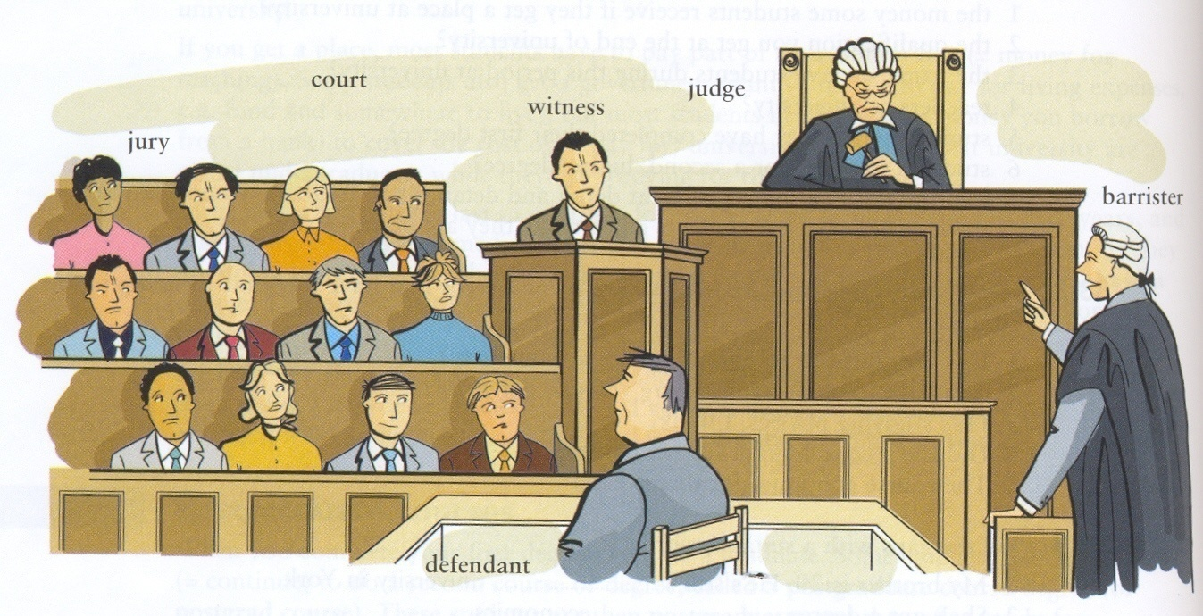

5.1b Nouns associated with criminal courts and the law
Noun | Definition | Choose from
_____________ | a formal examination in a court of law to decide whether an accused person is guilty or not guilty | felony  trial  verdict  evidence  misdemeanour  testimony  judge  jury
_____________ | a very serious crime, such as murder or robbery
_____________ | a crime that is less serious than a felony, such as vandalism
_____________ | information presented during a trial
_____________ | statements of a witness under oath during a trial
_____________ | group of impartial citizens who decide whether the accused is guilty or not
_____________ | the decision: guilty or not guilty
_____________ | the person who leads a trial and decides on the sentence if there is one
5.1c In court
In court, the defendant must try to prove (= provide facts to show something is true) that they did not commit the crime. In other words, they must try to prove that they are innocent (opp guilty). Twelve members of the public (called the jury) listen to the evidence (= information about the crime, for and against) and then make their decision. People who see a crime are witnesses, and they usually give evidence at a trial.
If you are in custody, you are kept in jail. You could be released on £1000 bail. Bail is money you lose if you fail to appear in court.

5.2 The criminal justice process

5.2a LISTENING 6
You are going to hear a summary of the criminal justice process in England and Wales. Try to complete as much of the chart below as you can using the words in the box.

refer acquitted sentenced pleads (x2) remanded
proceeds dropped prosecute granted

1 - The police have enough evidence to charge the suspect.
The police p_____________ the suspect. |  | The police r____________ the case to the Crown Prosecution Service (CPS).
2 - The CPS reviews the case and decides whether or not to proceed
(is there enough evidence?)
The charges are d______________. No further action is taken (NFA). |  | The CPS p_____________ with the case.
3 - The suspect is g____________ bail or is r________ in custody until the trial.
The suspect (now a defendant) goes home until he/she is summoned to court. |  | The defendant absconds (sich der Festnahme entziehen).
4 - First appearance in court
The defendant p___________ guilty and is sentenced. |  | The defendant p_____________ not guilty – a date for the trial is set.
5 - At the trial, the prosecution lawyer presents the evidence against the defendant. The defendant’s solicitor challenges the evidence and presents a defence.
The defendant is found not guilty and is a________________. |  | The defendant is found guilty and is s_________________.
5.3 Grammar – The Passive

5.3a Focusing on the action
grammar at work
Using the Passive

The PASSIVE is used:
- in formal, official correspondence or writing
- when the person or thing causing the action is unknown or unimportant
- when the focus is on the activity itself, not on who or what caused it

Your application will be forwarded to the relevant department. | (the applicant doesn’t need to know it’s Ms. Huber who will do it!)
Our house was built in 1732. | (who cares what the many builders’ names were!?!)
Police cars were overturned, windows were broken, and five officers were injured. | (we know it was the demonstrators who did it, but we’re more interested in what happened to the cars, the windows, the officers…)

In the passive, it is nevertheless possible to mention who does the action (the agent):

The broken windows were repaired by the city.

5.3b Practice - Passive (no modals)
Fill in each of the gaps in the following newspaper extracts using the passive.

- Four people _____________________________ (charge) last night with public disorder offences after officers mounted dawn raids on suspected football hooligans.
- The police in Scotland are calling for the introduction of leg-restraints following concerns about the number of injuries which _________________________ (cause) every year during struggles in the back of police cars and vans.
- A British woman __________________________________ (just / release) from police custody in Thailand. She _____________________________ (take) into custody three weeks ago on suspicion of drug possession.
- Plans __________________________________________ (currently / discuss) to introduce a “Big Brother” program of mentoring in our community where juvenile delinquents _________________________ (pair) up with adults who try to get them on the right track.
- He’s only 14 years old, but he _____________________________ (catch) joyriding already six times.
5.3c Passive with modals
grammar at work
Using Passive with Modals

The passive form for modals is formed as follows:
present | modal + (not ) + be + past participle | could be sent  might be arrested  may not be released
past | modal + (not ) + have been + past participle | should have been told  could have been warned  might not have known

Look at the following sentences:
Jack Thatcher should be sent to prison so he can’t commit any more crimes.
Offenders ought to be rehabilitated so that they can learn to function in society.
5.3d Rewrite the sentences, using the passive.
- They should arrest the drug dealer.
________________________________________________________________
- The court might send the defendant to prison.
________________________________________________________________
- The victim should report the crime to the police.
________________________________________________________________
- They ought to take the child away from his parents.
________________________________________________________________
- The judge may sentence him to life in prison.
________________________________________________________________
5.3e Decide whether to use the active or the passive.

The police __________________________ (should / arrest) all demonstrators who become violent. Protective riot gear __________________________ (must / wear) at all times. Handguns _____________________________ (must / not / draw) unless absolutely necessary. Demonstrators __________________________ (might / attack) if they feel threatened. The demonstration __________________________ (could / get) out of hand if the situation becomes aggressive. Efforts __________________________ (must / make) to deescalate whenever possible.
5.3f Complete the story
Insert the right word in the form provided in the correct blank. Which of the ideas in the text below are expressed in the passive?

suspected
convicted
arrested
heard
questioned
charged

A few months ago Ron was ⁽¹⁾ _____________________ by the police, who
⁽²⁾ ___________________ him of being involved in a robbery at a local post office.
He had been ⁽³⁾ _____________________ previously of petty crime, but never anything serious. The police ⁽⁴⁾ _______________________ him for several hours and finally
⁽⁵⁾ _______________________ him with robbery. A few weeks later he got a letter saying that he had to appear in court the following month when his case would be
⁽⁶⁾ ______________________.

5.3g Talking about a trial
Fill in the blanks with the right verb in the right form (possibly passive!) to talk about a trial.
sentence * try * convict * defend * serve * acquit * find

Two men ⁽¹⁾ ________________________ in court yesterday for murder. One of the two accused men ⁽²⁾ _________________________ at yesterday's trial. Although his lawyer
⁽³⁾ ____________________ him very well, he ⁽⁴⁾ _______________________ guilty by the jury. Because the crime was a felony, the judge ⁽⁵⁾ _____________________ him to twenty years in prison. He'll probably ⁽⁶⁾ _______________________ less than fifteen years of the sentence. The other accused man was luckier. He ⁽⁷⁾ _______________________ and left the courtroom smiling.

5.4 Crime doesn’t pay
LISTENING 7 – Listen to two stories about trials.

 | What was the person tried for? | What happened at court?
Story 3
Story 4

5.5 Grammar – Past Perfect

5.5a Talking about actions that happened BEFORE others
grammar at work
Using the Past Perfect

We use the past perfect to explicitly say that something happened or was completed BEFORE something else in the past:
By the time the police arrived, the thief had already run away.
The police looked for the murder weapon, but the culprit had hidden it under the couch.
The bomb went off at dawn. The bomber had apparently deposited the explosives during the previous night.

5.5b LISTENING
Listen again to Story 2 from Listening 3. As you listen, complete the text with the missing verbs (simple past or past perfect). Some will be in the passive!

“In London today, a very unusual story about the perfect crime that went wrong – the bank robbery that failed.
Everything seemed to be just right. The timing _____________________________ (plan) to the minute. The escape route was ready. Even the hiding place for the money _________________________________ (carefully / prepare). The getaway driver ______________________________ (handpick) as someone who could be trusted.
The robbery _____________________ (go) without a hitch. And the robber _______________________ (run) out of the bank with £100,000 in cash. Unfortunately for the robber, Wayne Smith from East London, when he ____________________ (reach) the getaway car, his friend, the driver, wanting to make the escape as fast as possible, _________________________ (run) him over.
Smith and his accomplice are both in hospital tonight where they are reported to be in a stable condition.”

Put the following events in order relative to the robbery:

preparation of hiding place
injury of Smith
selection of driver
hospitalization
attempt to flee

robbery
x
x
TIMELINE OF EVENTS

5.5c Practice – Simple past or past perfect?
Now complete the following sentences, deciding whether to use the simple past or the past perfect. There may be passives as well!
Long-Finger Joe ________________________ (try) in court yesterday for the murder of a woman. On February 14, 2020, he _______________________ (attack) a woman he ___________________________ (never / meet) before – simply because his girlfriend ___________________________ (break) up with him that morning! The judge __________________________ (find) him guilty and _____________________ (sentence) him to 20 years in prison. After the verdict was read, Long-Finger Joe _________________ (tell) the press he _________________________ (never / commit) a crime before. It was his first public statement since he ______________________________ (arrest) for the crime.

6. PUNISHMENTS

6.1 Punitive measures
Punishment (= what a person must suffer if they do something wrong) – Choose the correct word related to punishments to complete the definitions or examples.
death penalty * fine * on probation * community service * capital punishment * tagging * prisoner * sentence * suspended sentence * probation officer
- For crimes that are not serious (called minor offences, e.g. illegal parking), the punishment is usually a ___________________. (= money you have to pay)
- If someone is guilty of a crime, the judge will give the ______________________ (= the punishment). If a person is guilty of murder, the sentence may be 10-20 years in prison. The person then becomes a ______________________.
- The ______________________ or ______________________ has been abolished in many countries. It has been brought back in some states in the United States, where people are executed usually by lethal injection.
- If you are given a _______________________, you only have to go to prison if you commit another crime within a certain period of time.
- If you are ______________________, you stay at home, but you have to report regularly to and receive help from a ______________________. For a less serious offence, committed particularly by a young person, _________________________ is often a more appropriate sentence.
- _________________________ is when a prisoner is allowed home, but is fitted with an electronic 'tag' so that the police know where he is.

6.2 Passive for punishments
Choose the correct ending for each sentence stem (in the passive):
1. She was sent
2. He was sentenced
3. First offenders can be put
4. She was fined
5. He was banned
6. They were let
a. to life imprisonment / to death.
b. from driving for three years.
c. to prison for 3 months.
d. off with a caution.
e. £200.
f. on probation.

6.3VIDEO 5 – How offenders are sentenced in England and Wales
https://www.youtube.com/watch?v=M4CIveEDtmk

0:52 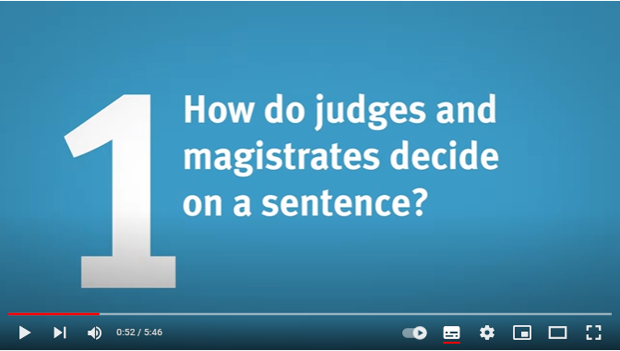 | - The punishment should fit the c_______________.  - There are sentencing g______________ to help judges and magistrates sentence the same way.  - Every crime and offender is d________________. No two cases or victims is the s______________.
1:32 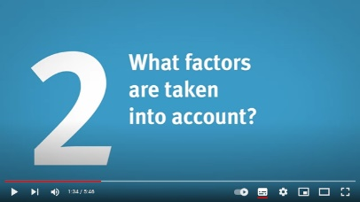  First, complete the left column.  Then match with the meaning on the right.
  Factor | Meaning
  - s__________________ | - guilty of other crimes before
  - h__________________ | - physical injury, psychological effects
  - b__________________ | - come clean, admit guilt
  - previous c__________________ | - truly sorry
  - personal c__________________ | - how serious the offense is
  - r___________ | - planning, using a weapon, targeting a vulnerable victim
  - g__________ p____________ | - e.g. having to look after family members
3:56 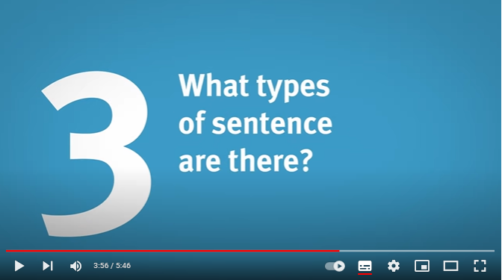
  Sentence | Uses | Details of Sentence
  - __________________ | the toughest sentence, for most serious crimes | ½ in _____________, ½ on license (obeying certain rules such as _______________).
  - __________________ | punish through unpaid work,  to help offenders stay out of trouble | between ______ and ______ hours of work
  - __________________ | for less severe offenses | depends on seriousness of crime and how much __________ the offender has
  - __________________ | least serious offenses, the experience of going to court is punishment enough! | may come with con__________; the offender may have to serve the sentence if ______________________.

6.4 Community payback
Read the text below about community payback and answer the questions.
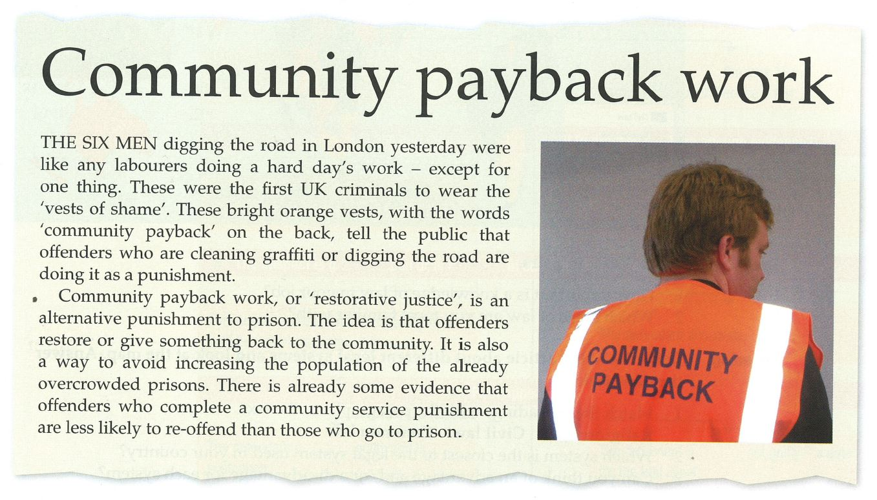

Complete the sentences with words from the text.
- To ‘restore’ is to give _______________________________.
- Prisons in the UK have too many people in them. They are ___________________.
- People who go to prison are more likely to __________________ than those who do community service.
- Offenders often feel _____________ when people recognize them in the orange vests.


Discussion
- Does community payback exist in your country?

- Do you think it is an effective punishment for crime?

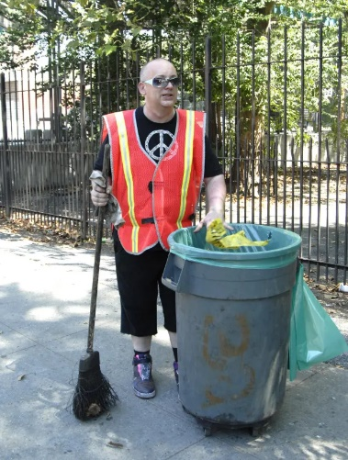
- What types of work could/should be given to offenders to give back to the community?

6.5 Grammar – The Future Tense

6.5a - There are four main ways to express the future:
- spontaneous decisions  - predictions (no evidence)  - offers, promises, threats  - with certain expressions: think, hope, expect, I’m certain, certainly… | - intentions and decisions  - predictions (with evidence) | - personal arrangements and appointments | - official timetables and schedules
will + inf. | going to + inf. | pres. continuous | present simple
LEAST CERTAIN MOST CERTAIN
I think it will be a cold winter. | He is going to split up with his girlfriend. | They are having dinner with their in-laws tonight. | The exam takes place at the end of June.
But what do I know?! I’m not a meteorologist! | He’s been talking about it for a while… | It’s been arranged - maybe even a table has been booked. | Very official.

6.5b Future – Practice
Complete the following sentences, using the appropriate future tense form.

- Tomorrow afternoon I ____________________ (meet) one of my co-workers to discuss our next assignment.
- Deborah: What time does your shift start tonight?
Francis: It _______________ (start) at 6:00 p.m.
- Gerry: Wow, my books are really heavy!
Danny: Here, I ___________________ (carry) some for you.
- I think we __________________ (pass) the exam if we study enough.
- According to the schedule, class _____________________ (end) at 5:00 p.m. But if our tutor runs over again, it ________________________ (probably / end) at 5:15 p.m.
- Simon: What ______________________ (you / do) this weekend?
Kevin: I don’t know. I _______________________ (probably / go) hiking. And you?
Simon: I ____________________ (go) on a boat trip down the Danube. Everything is planned. I’ve got my reservations already.
- “Pay more attention to your child! The dog _______________________ (bite) him if he keeps pulling its tail! He’s bitten people before!”
- George: Have you still got my CD?”
Isabella: Oh, yes! Sorry! I _________________ (give) it back to you tomorrow.
- We have made up our mind – we __________________________ (sell) our car. We have already made an appointment to talk to a car dealer next week about buying a new one. We ___________________ (meet) him on Wednesday at 9:00 a.m.
7. WRITING SKILLS

As the foundation for all of your written work in your
English courses at the university, we will be looking at some important elements related to writing skills:

7.1 – The paragraph & its structure
7.2 – Topic sentences
7.3 – Supporting arguments
7.4 – Concluding sentences
7.5 – Connecting ideas
7.6 – Punctuation
7.7 – Register (formality)

These topics and pages will be useful resources for all of
your written work in English in the following semesters.

7.1 The Paragraph & its Structure

What is a paragraph?
A paragraph is a group of sentences about ONE topic. All the sentences explain the writer’s main idea about that topic.

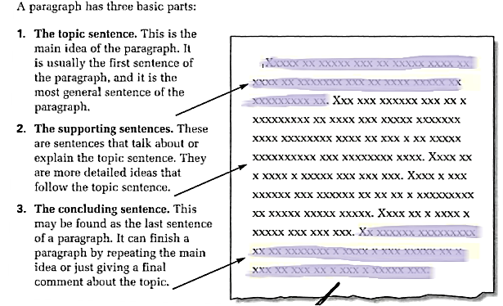

Practice
Read the following paragraph and identify its three main sections (topic sentence, supports, conclusion).

There are a number of reasons why being a police officer is preferable to other professions. The first is that the job of a policeman is a very secure one. Austria will always need law enforcement officers because people will always break the law. Furthermore, as an employee of the state, police officers usually need not fear losing their jobs unless they have done something seriously wrong. Another reason why it is desirable to be a police officer is that it is a very rewarding job. When crimes or accidents occur, a police officer is there to assist victims or injured persons who need help. Finally, this job offers a great amount of variety. Unlike typical desk jobs, a police officer works outdoors as well as indoors, and his duties vary from writing reports to patrolling to testifying in court. For all these reasons, I consider being a police officer to be one of the best jobs that exist.

7.2 Topic Sentences
- Do not start a new text straight away with the first major argument.
- Introduce the topic in the first sentence, which is the topic sentence. A topic sentence introduces the main idea of the paragraph and consists of two parts: the topic and the controlling idea.
- There are three main ways of how to create topic sentences:
1. Express opinion | The company’s Halloween party was a real bore this year.  Being an effective police leader is very difficult.
2. Show parts | Planning a good training session requires three steps.  There are four main aims of punishment in today’s society.
3. Rephrase question | Q: | What sort of crimes¹ do young people often become implicated in²?
 | A: | Juveniles frequently get involved in² various types of illegal activity¹. For instance they…

Now try it on your own:
Formulate topic sentences for the following assigned topics or tasks:
- What do you think are the most important duties of a police officer?

- In your opinion, what role does the internet play in modern-day crime?

- What is the best way to deter young people from breaking the law?

7.3 Supporting Sentences
A supporting sentence develops the topic sentence and consists of a main idea and supporting evidence. Supporting evidence can:

show the reason
illustrate a point
(i.e. give an example)
show the effect
provide a contrast

7.4 Concluding Sentences
Each paragraph ends with a concluding sentence which
- returns the reader to the topic at the beginning of the paragraph (restating the main idea, although in different words),
- summarises the paragraph,
- or which acts as a connector to link the information with that coming up in the next paragraph.

7.5 Connecting Ideas

Take a look at the following excerpt from a text. Is it a well-written text? Why or why not?
I have been a police officer since 1998. It was my childhood dream. I wanted to be a police officer because the job is very exciting and different to other jobs. The pay is generally good. Sometimes the hours are irregular. I do shift work. The stress level can be quite high. …

Remember, a paragraph is not a list of sentences. These sentences should be related in terms of subject, and they should also be connected through the use of language.

Example 1 – The following two sentences can be connected:
 | I wanted to be a police officer because the job is very exciting and different to other jobs. | + | The pay is generally good.
I wanted to be a police officer because the job is very exciting and different to other jobs. In addition, the pay is generally good.

The author begins by talking about the positive aspects of the job. Then s/he adds another one using a linker for adding ideas.

Example 2 – The following two sentences can be connected:
 | The pay is generally good. | + | Sometimes the hours are irregular.
…The pay is generally good. However, sometimes the
hours are irregular…

First, the author talks about a positive aspect of the job. Then s/he mentions a negative aspect about being a police officer using a linker for contrasting.

By using cohesive devises
(transitional words, linkers),
you can connect your sentences and ideas to make your train of thought clearer to your reader.

7.5a Linkers

Introducing a new idea explicitly | Sequencing | Giving examples | Contrasting
- concerning  - as for…  - as far as … is concerned  - regarding | - while  - when  - before  - after  - next  - since  - to begin with  - first (of all)  - the first point …  - second  - finally | - in general  - generally  - for example  - for instance  - specifically | - however  - nevertheless  - in contrast to that  - on the other hand  - yet  - but*  - in spite of  + noun or –ing form  - instead of  + noun or –ing form  - despite  + noun or –ing form  - although#  - whereas#

Adding information | Stating cause and effect |  | Concluding ideas
 | Cause | Effect
- and  - also  - in addition  - in fact  - moreover  - another… is/was  - in particular  - furthermore | - because*  - since  - due to + noun  - due to that  - due to the fact that… + verb clause  - owing to + noun  - on account of  + noun  - as a result of + noun | - so*  - thus  - for that reason  - therefore  - as a result | - in conclusion  - in summary  - therefore
*informal
#Contrasts with these words require two phrases (each with a subject and verb) separated by a comma:
Although we were late, we made it to the party on time.

7.5b Practice

For each example, link the two sentences with the linker provided. For some examples, you may have to slightly reformulate your sentence to fit the linker. The first one has been done for you.

- He couldn’t sleep. There was a lot of noise. OWING TO
Owing to the noise, he could not sleep.

- She accepted the job. The salary was quite low. ALTHOUGH
- She accepted the job. The salary was very high. AS
- The letter did not arrive. It was Sunday. THEREFORE
- The fog was intense. We could not see the road. DUE TO
- My sister sings well. My brother is a good athlete. WHEREAS
- English is a fascinating subject. It is useful for travels. FURTHERMORE
- Organic food is good for the environment and our health. It is expensive.
HOWEVER
- Organic food is expensive. I do not buy it very often. THUS
- We did not go to the cinema. We went out to dinner. INSTEAD OF
- It was raining. We went for a walk. IN SPITE OF
- Knife attacks in Great Britain are rising. The police have increased patrols.
ON ACCOUNT OF

7.6 Punctuation
Use of the Comma


Never

Before noun clauses that depend on the verb (i.e. never before "that")
Example: | She said | that she had booked her holiday.
 | It is clear | that this will be a problem.
 | They never told him | what to do.
 | She asked them | if there were any problems.


Always

Before "which" referring to a whole clause
Example | Try it yourself
Beethoven composed many of his famous scores even though he was deaf, which is hard to imagine. | They said they would be able to deliver within the same week which I find hard to believe.


Normally

To separate main clauses connected with "but", also with "and, or" (esp. if subject is expressed and when longer)
Example | Try it yourself
She asked him to make sure the windows were closed, but he didn't do it. | They ought to lower their prices or customers won't buy anything from them.

To set off adverbs, prepositional phrases and sub-clauses at the beginning of sentences, e.g.:

1. Linking adverbs: a.o. "however, nevertheless, moreover" etc.
Example | Try it yourself
They thought they would be back within the week. However, things turned out differently. | Everybody considered their prices too high. Nevertheless they received a good number of orders.

2. Comment adverbs: a.o. "luckily, unfortunately, clearly" etc.
Example | Try it yourself
A major storm was approaching fast. Luckily, they had closed all the windows. | In our last letter we promised delivery by the end of the month. Unfortunately we will not be able to keep this date due to technical problems.

3. Subclauses, non-finite clauses ("-ed", "-ing") and prepositional phrases BEFORE the main clause
Example | Try it yourself
Ignoring the rain, they kept hiking.  In spite of the rain, they kept hiking.  Although it was raining heavily, they kept hiking. | Wherever they were trying to sell their products they were told that the price was simply too high.

7.7 Style & Register
Depending on the situation, the writer’s language needs to be adapted in order to be appropriate. Some situations call for a relatively informal style. However, professional and academic writing are generally more formal. Here are some tips to achieve that.
  Don’ts: |  |   Do’s:
1. Limited use of I |  | Only acceptable when giving your opinion. Use sparingly.
2. No personal pronouns  in generic meaning  (you – he / she – we) | You can reduce crime by encouraging community policing. | In English the German “man” can be expressed by using the pronoun you. However, in formal writing this is not acceptable. To avoid using personal pronouns in generic meaning you can:  - use the passive:  Crime can be reduced by encouraging community policing.  - use an alternative third person plural noun or they:  Governments can reduce crime by encouraging community policing.  - use an “It is + adjective construction”:  It is possible to reduce crime by encouraging community policing.  However, it is not always possible to use all three possibilities for every idea…
3. No contractions | haven’t  she’ll | have not – she will – is not – cannot – there is
4. No use of vague phrases | somehow, kind of, sort of, and so on | Just leave them out!
5. No use of thing | There are three things to consider. | Use other words such as aspect, point, detail, fact, etc. depending on the context.  There are three aspects to consider.
6. No use of get¹, need², take³ or make⁴, do⁵ |  | Use more formal and more specific words such as obtain¹, require², accept³, earn⁴, perform⁵ etc. depending on the context.

7.7a Practice 1 – Use the ideas in Tips #1 and #2 to avoid using 1st/2nd person
- You can sell these goods on the black market at a higher price.
- We have to develop a new strategy for dealing with crime against the elderly.
- You should invest more money in the equipment of our patrol cars.
- I think these changes will lead to more serious problems.

7.7b Practice 2 - Avoiding informal register
_{became}
EXAMPLE: He got very angry towards the end of the meeting.

- She got this letter yesterday.

- She gets a lot of money in her new position.

- He needs to get more experience.

- The situation will get worse before it gets better.

- He had the chance to meet the police Superintendent of New York last week.

- There is little chance that the suspect will be caught.

- The time of this meeting is not OK.

- The Ministry will not give the OK to this project.

- These two theories are similar in many ways.

- The IT team should find a new way to format the data.

- Online banking enables people to do their banking in a more efficient way.

- Another problem which it is necessary to talk about at the meeting is the high personnel costs.

- The team leader needs to think about the following things.

- Maybe the management will make a new strategy for young police officers.

- This plan has many pros and cons.

- Unemployment has increased, so crime will rise for sure.

- There were lots of problems during the crowd control operation.

- This change will not make a big difference to the situation.

- The crime rate in Sweden is far lower than in Austria.

- Western European cities like Vienna and Paris are very popular targets for international crime gangs.

7.7c Practice 3
Replace the underlined informal elements with more formal expressions.

Managers can make lots of mistakes. One is not to give feedback. If people don’t get feedback, they do not get the chance to do their work better. So you as a manager cannot get the best out of them. Another bad thing is that some managers don’t want to give important tasks to others because they think that no one can do them as well as they could themselves. So they have a huge workload and the others are unhappy because they never get the chance to do anything interesting. And another mistake that you may make as a manager is not to tell workers about your goals. If they don’t know about the goals, how can they reach them?

7.7d Practice 4
Rewrite the above paragraph to improve the overall expression and its structure.

GLOSSARY
NOTE: The words shaded in blue are ones you should know for the exam.
English | German
Courts/Powers
Administrative Court | VwGH
Constitutional Court | VfGH
District Court | Bezirksgericht
Regional Court | Landesgericht
juvenile court | Jugendgericht
Higher Regional Court | Oberlandesgericht
Supreme Court (US), High Court (UK) | Oberster Gerichtshof
Execution of the law / court dealings
to accuse | anklagen
to interrogate | verhören
interrogation | Verhör
search warrant | Durchsuchungsbefehl
house search | Hausdurchsuchung
warrant for arrest | Haftbefehl
evidence | Beweis
investigation | Untersuchung / Ermittlung
trial / hearing | Verhandlung
judge | Richter
jury | Geschworene
lawyer/attorney | Rechtsanwalt
(public) prosecutor | Staatsanwalt
lay assessor | Schöffe
innocent | unschuldig
confession | Geständnis
to sentence /convict | verurteilen
People involved in proceedings
judge | Richter
(public) prosecutor | Staatsanwalt
lawyer, attorney | Anwalt
suspected person / suspect | Beschuldigter
victim | Opfer
injured person / claimant | Geschädigter
criminal / delinquent | Verbrecher
juvenile delinquent | jugendlicher Straftäter
complainant / plaintiff | Kläger, Beschwerdeführer
witness | Zeuge
defence lawyer (BE) / defense lawyer (AE) | Verteidiger
(Court) Proceedings /Decisions
to accuse / to indict | anklagen
to prosecute | strafrechtlich verfolgen
to take (legal) action | gerichtl. gg jemand vorgehen
to claim compensation | Schadenersatz fordern
to give evidence | Zeugenaussage machen
to testify | vor Gericht aussagen
to make / give a statement | Zeugnis ablegen
to seize / confiscate | beschlagnahmen
to be previously convicted;  to have a criminal record | vorbestraft sein
to acquit | frei sprechen
acquittal | Freispruch
(in)admissible (evidence) | (un)zulässig
police / (judicial) interrogation / questioning | (polizeiliche/richterliche) Vernehmung
charge | Anklage
verdict | Urteil
testimony / statement | Zeugenaussage
crime(s) | Verbrechen/Straftaten
misdemeanor | Kleinkriminalität
arrest / imprisonment / detention | Verhaftung
personal search | Personsdurchsuchung
prison / jail | Gefängnis
penitentiary | Strafanstalt / Justizvollzugsanstalt
imprisonment | Haftstrafe
appeal | Berufung
to allow an appeal | einer Berufung stattgeben
to dismiss an appeal | eine Berufung zurückweisen
(Degrees of) punishment
punishment | Bestrafung
fine/penalty | Geldstrafe
to impose a fine on someone | über jmd eine Geldstrafe verhängen
prison sentence | Freiheitsstrafe
life imprisonment | lebenslängliche Freiheitsstrafe
unconditional sentence, without probation | unbedingte Verurteilung
suspended sentence, with probation | bedingte Verurteilung
to sentence | bestrafen (durch Richter)
enforcement of sentences | der Strafvollzug
detention | Untersuchungshaft
to be on remand, to be (detained) in custody | in U-Haft sein
prisoner on remand | U-Häftling
to be found guilty of | für schuldig befunden werden (vom Gericht)
to be guilty of | für schuldig befunden werden (von d. Polizei)
to appeal | berufen
to file charges | Anklage erheben
charges | Anklagepunkte
electronic shackles, electronic tags | elektronische Fußfesseln
parole | bedingte Haftentlassung/Strafaussetzung
parolee | bedingt Entlassener
to be released on parole | auf Bewährung frei gelassen werden
without parole | ohne vorzeitige Entlassung
parole officer | BewährungshelferIn
to abolish the death penalty | die Todesstrafe abschaffen
detoxication treatment | Entziehungskur

